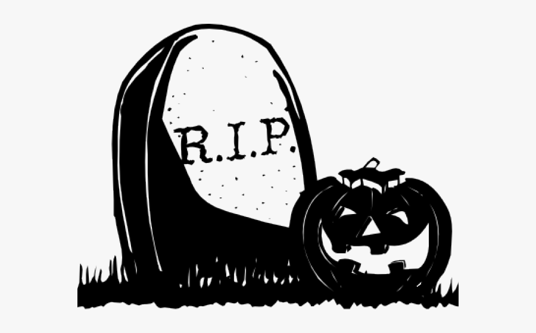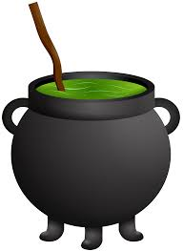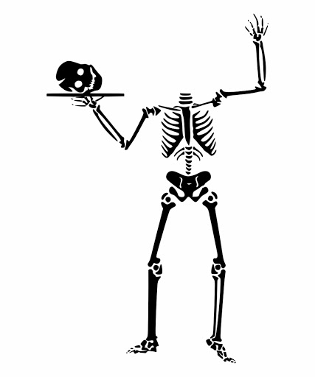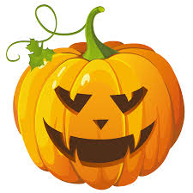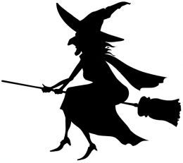

***Included in the pack:***

* Plain A5 card
* Envelope
* A pack of images to cut and stick on the card if you choose to use them
* An example card from me
* Orange craft paper
* Black craft paper
* Selection of tissue papers

You might want to draw some elements and colour them in to create a mixed media piece or complete the whole card as a collage.

***You will need:***

- Glue stick

- Scissors

- Pen

- Colouring Pencils / Felt Tips

- Pencil

***Tip:*** You could use the craft paper to create a background or draw shapes on the coloured card to be cut out and stuck onto your card.

***Task:*** To create a Halloween themed collaged card to send back to Borderland Voices.